ANTARES JUNCTION BOX – MECHANICAL EXECUTIVE DESIGN AND MANUFACTURING

M. Ameri¹, M. Anghinolfi¹, P. Cocconi¹, S. Cuneo,¹ R. Papaleo², F. Parodi¹,
P. Prati¹, G. Raia², A. Rottura¹
¹ Istituto Nazionale di Fisica Nucleare ,Sezione di Genova via Dodecaneso, Genova, Italy
² Istituto Nazionale di Fisica Nucleare , Laboratori nazionali del Sud, via S. Sofia, 44 Catania, Italy

Abstract
This report describes the executive design and specification of the junction box container, complying with the requirements stated in the previous Antares official documents (1), (2), (3).
Structural, thermal, corrosion, manufacturing and quality assurance considerations have been made, to produce a design that could both comply with the requirements and ensure a high reliability, trying to find a good cost compromise too.
- CONSTRAINTS AND REQUIREMENTS
  - Layout
The JB is required to house the components listed in the table below. The main transformer has to be located in a separated, watertight compartment inside the JB, that must be filled with dielectric oil for cooling. The components in the other compartment have to stay in dry atmosphere, to avoid condensate on the cold walls while under sea.

ITEM | DESIGNATION | LENGTH | WIDTH | HEIGTH | N°
[-] | [-] | [mm] | [mm] | [mm] | [-]
1 | main transformer | 330 | 350 | 600 | 1
2 | Clock module | 320 | 200 | 20 | 1
3 | ROR electronic-optic | 110 | 170 | 50 | 1
4 | Output breaker/switch | 130 | 140 | 150 | 16
5 | low voltage supply | 370 | 115 | 100 | 1
6 | Timed relay | 210 | 121 | 56 | 2
7 | short mode relay | 140 | 90 | 56 | 1
8 | JB control module | 300 | 115 | 100 | 1
9 | EOC-copper 5 kV terminal | 110 | 170 | 150 | 1
10 | Electrode terminal | 110 | 170 | 50 | 1
11 | 1000 V terminal | 110 | 170 | 50 | 1

The following openings are required:
- 16 holes for the electro-optical cables connecting the strings to the JB;
- 1 hole for the main electro-optical cable coming from the shore;
- 1 hole for a test penetrator;
- 1 hole for the high voltage return.
As two titanium spherical caps are already available (see fig. 1), it is strongly advisable to use them for cost savings.
  - Operating conditions
The JB is required to operate in the following environmental conditions
- Operating pressure int/ext : 0 / 256 barg;
- Test pressure int/ext : 0 / 310 barg;
- Operating temperature : 13.2°C;
- Lifetime : 10 years.
  - Thermal exchanges
The electronics inside the JB is expected to produce an heat loss of around 1200 W, mainly due to the transformer. This power has to be drained away through the walls of the JB, without increasing the temperature of the electronics above the maximum allowable operating value.
- DESIGN OF THE STRUCTURE
  - Components layout
As the space enclosed by the two existing spherical caps wasn’t enough to house all the components, the only way to use them was to foresee in between a spacer annulus to increase the available volume.
We built a CAD and a physical model (see fig. 2) with a 300 mm high spacer, and that configuration showed to satisfy the room as well as the cables and optical fibres minimum bending radius requirements.
The main drawback of this solution is that implies one more potential source of leakage, as there are two mating flanges instead of one, that is the reliability is lower. Then we carefully faced the seal designed, as described below.
  - Materials
The existing titanium spherical caps were made of BT-23, an alloy common in Russia, whose properties and characteristics are summarised in the table below, and that is known to withstand very well the chemical attack in sea water. The best choice would then have been to employ the same material for the annulus spacer, but a quick market survey gave us evidence that that kind of alloy requires a long procurement time, not compliant with our time schedule.

MATERIAL | COMPOSITION |  |  |  |  | Rs | Rp_{0.2} | ρ | δ
 | [% Al] | [% Fe] | [% Mo] | [% Cr] | [% V] | [MPa] | [MPa] | [Kg/m3] | [%]
BT-23 | 6 | 0.5 | 2 | 1 | 4.5 | - | 960 | 4600 | 14
Ti 6 Al 4 V g. 5 | 5.5-6.8 | 0.4 | 0 | 0 | 3.5-4.5 | 895 | 828 | - | 10

We then decided to use a standard ASTM alloy Ti 6 Al 4 V, commonly known as “titanium grade 5”, whose characteristics (see table above) are very similar to those of the BT-23. While the ASTM alloy gave the same guarantees from the point of view of the corrosion in sea water, we had a little concern about the electrochemical compatibility of the two different alloys in contact in salt water. Then we measured the electrode potential of two specimens of the two alloys, that proved to be very similar, so that no electrochemical is expected to happen.
As the two compartments inside the JB are filled with dielectric oil (transformer side) or dry gas (electronics side), no electrochemical corrosion is expected if two different metals are there in contact; then we decided to manufacture the separation diaphragm in AISI 316 stainless steel, quite cheaper than titanium. Furthermore, as that diaphragm will have to support all the components and the static pressure of the oil, AISI 316 gives also the advantage of an higher Young’s modulus, that means a smaller bowing under static load.
Finally, we decided to use Viton for the O-ring seals, as it should better withstand the chemical attack of both sea water and dielectric oil with a longer lifetime (around 20 years) compared to other elastomeric compounds.
  - Structural and stability considerations
The stress of the structure under test pressure load , as well as the displacements of the mating surfaces with the spherical caps, have been verified with a FEA model. The simulation showed that the higher stresses are just next to the penetrators holes, as expected because of the known phenomenon of the stress concentration (see fig. 3) . Nevertheless, with a design thickness of 53.5 mm, the safety factor, compared to the minimum guaranteed yield strength of the material (828 Mpa), complies with the requirements stated by the Italian normative for pressure vessels both in test and operating condition.
Furthermore, such a high thickness allows to reduce the differential shrinkage between the spacer annulus and the spherical caps, that have also been verified with a FEA model (see fig. 4) down to 0.5 mm, then minimising the friction to the O-ring seals. Anyway, the screws diameter has been defined so that both components could freely shrink, being the friction the only action interchanged. For the same reasons, the outer diameter and the screw holes of the stainless steel diaphragm have been designed taking into account of some extra clearance.
Finally, a stability check has been done, using the formulas given by the VSR Italian normative for pressure vessel (that, in fact, replies the prescriptions of the main international technical boards), that are really precautionary but all the same confirmed that the annulus could withstand the load with a safety factor large enough.
As a final check, we commissioned the supplier of the spacer to submit a calculation report, where a qualified engineer states that the design of the spacer complies with the structural requirements.
  - Geometry overview
As already stated, the inner volume is divided into two watertight compartments: the upper one locates the transformer in its own dielectric oil bath, while the lower one houses all the other electronic components (see fig. 2). This layout should help the thermal insulation of the two compartments.
The two compartments are separated by means of a stainless steel diaphragm, that also supports all the components; it rests on a step machined on the inner surface of the spacer, while the tightness is given by an O-ring seal. The electrical connections between the two compartments are made with leak-tight feed-through connectors. If the final temperature constraints of the electronic components (mainly the opto-electronic ones) will be relaxed, the JB will be simply capsized on it rests, to reduce the probability of oil leaks, then improving the reliability.
The penetrators enter the JB through the spacer annulus, that then features 16 holes almost equally spaced, and then get into the lower compartment. The main cable enters first an intermediate, small box, that houses a terminal board and should make it easier the connection while on the boat during the JB deployment operation (see fig. 5); this intermediate box, on its turn, is flanged to the spacer annulus and communicates with the lower compartment. As the main cable termination hasn’t been defined in detail yet, the above mentioned solution has to be considered a s a proposal. The high voltage return penetrator, as well as the test penetrator, are installed in the spacer annulus, roughly opposite to the main cable entry, and communicate with the electronics compartment.
The spacer annulus features two journals that allow the whole JB to be overturned, while resting on its supporting frame, for easier assembling and maintenance.
  - Penetrators
Different types of penetrators for the cables connecting the strings to the JB have been evaluated. As the cable connector choice, that is the most expensive part of the line, drives the choice of the penetrator, we agreed with all the suppliers in competition that their penetrators would comply with the following parameters, that define the interface penetrator-JB:
- Hole bore diameter : Φ1.25”^{+0.002+0.000}
- Screw holes : 6 x M8 on Φ 2.6”;
- Flange outer diameter : Φ 3.35”.
This philosophy allows to be compatible with all the suppliers that are tendering for the bid of the cables connectors, then keeping the competition alive among them.
  - Main cable inlet box - proposal
The termination of the main electro-optical cable, while not precisely defined yet, is expected to require a bore of around 65 mm that, if drilled in the annulus spacer, would imply an unaffordable increase of the stresses. Furthermore, the experience previously done in deploying operations in open sea, showed that the connections between the cable and the JB could have been more reliable with a terminal board than with “plug-in” connector.
Both these considerations lead us to propose an intermediate JB (see fig. 6), made of the same alloy than the main one, large enough to house the terminal board and some device where to wind on the extra length of the optical fibres without bending them below the minimum suggested radius. A blind flange at the free end has been foreseen as “hand hole” to make the connections easier. As the main electro-optical cable has a minimum bending radius of 800 mm, it would have been hard to get straight into the intermediate JB without exceeding the overall dimensions of the frame: that’s why the intermediate box features a 90° entry of the cable.
Furthermore, due to the fact that the main cable doesn’t feature any barrier at its end and, in case of failure of its sheath, sea water would enter the JB, the main cable inlet box should house custom designed pressure tight penetrator, currently under study.
  - Pressure balancing device
While in operating conditions, the JB shrinks, because of the external pressure. Furthermore, the dielectric oil heats up and then increases its volume. As the transformer, for cooling reasons, must stay completely immersed in its oil, very little volume can be left empty in the upper compartment. Then the pressure acting on the stainless steel diaphragm would become too high. We estimated that an extra volume of around 5 dm3 would be required to compensate the above mentioned effects.
To overcome this problem, we proposed to install a balancing pipe that let the gas-filled volume on the top of the upper spherical cap (required not to have any oil expanding in the electronic compartment) communicate with the lower one, with its oil side end equipped with a floating plug that could allow to overturn the JB without oil flowing through the balancing pipe to the electronic compartment. On the other side, that pipe should be connected to one or more expansion pistons, to let the gas expand but preventing any oil vapour to enter the electronics compartment. This device is only at its conceptual design stage, and tests are foreseen to check its functionality and reliability before we decide to install it inside the JB.
  - O-ring seals
The existing spherical caps featured, on their mating flange, just one O-ring groove. As we introduced the spacer annulus in between, the number of joint surfaces had been doubled. That would result in a lower reliability, then we foresaw a second O-ring, concentric to the previous one.
As there was already a groove on one of the two existing caps, we decided to use it without re-machining. Re- machining the caps is an expensive operation, and could be risky. Then we designed the spacer with one groove on the surface that has to be screwed to the cap where there’s already a groove, and with two grooves on the other surface, that has to be screwed to the cap where there are no grooves.
Furthermore, to be precautionary against leakage, we specified that the O-rings had to be manufactured in one piece, without joints.
We found that a standard O-ring, complying with all our requirements, could fit only in the inner groove, machined on purpose, while for the outer O-ring we had to ask suppliers to set up a special, custom designed, mould.
  - Heat dissipation
As the power to be dissipated through the walls is not negligible at all, and reliability matters strongly suggested to be sure that the safety temperature limit wouldn’t ever been trespassed, we set up a FEA fluodynamic computational model. We considered a two dimensional symmetric model of the Junction Box.
We simulated the convective motion of the dielectric oil in two different layouts:
- transformer and dielectric oil in the upper compartment of the J B
- transformer and dielectric oil in the lower compartment of the JB
taking into account of the characteristic of a standard dielectric oil for electric transformers and their variations with temperature as shown in the table below:

Temperature  [°C] | Density  [Kg / m³] | Viscosity  [m² / s] | Thermal conductivity  [W / m °C] | Specific Heat  [J / Kg °C]
0 | 889.68 | 0.00009 | 0.145 | 1080.352
20 | 886.78 | 0.00003 | 0.143 | 1996.500
50 | 867.43 | 0.00001 | 0.1401 | 1996.722
100 | 835.18 | 0.000003 | 0.136 | 2185.092
150 | 802.93 |  | 0.131 | 2373.462
200 | 770.68 |  | 0.126 | 2561.832

In the simulation we took into account of the empty volume in the upper compartment of the JB. We then found the velocity and temperature distribution of the fluid inside the vessel (see figg. 7,8); the results of the simulation showed that:
- the transformer and the dielectric oil in the upper hemisphere of the JB is the best layout for power and temperature dissipation; the maximum temperatures calculated on the surface of the transformer in the two layouts are 44°C and 73°C respectively.
- the heat is easily drained out through the walls of the Junction Box.
As transformers are usually expected to operated in the range 70-80°C, both layouts look to be satisfactory; although a lower temperature profile is always preferable.
The calculated temperature of the oil under the transformer didn’t rise more than 10°C above the external wall temperature; as heat (around 200 W) is dissipated also in the electronics compartment, we don’t expect the temperature on that compartment to be below 25°C; then the heat transfer from the transformer to the electronics compartment shouldn’t be very important.
Nevertheless, the heat dissipation in the electronics compartment is not a negligible matter, as reliability reasons strongly suggest not to trespass the commonly accepted upper value of 50°C of environmental temperature. As the layout in that volume hasn’t been fixed yet, we couldn’t simulate accurately enough the thermal distribution and the fluid motion there. The first results just showed the heavy influence of the layout of the components, that should be studied in order to help the gas circulation, as well as the opportunity to foresee thermal bridges and shields. A forced cooling system, though greatly beneficial, wouldn’t be advisable from the reliability point of view and should be considered as a last chance.
The measurements made in the Genoa lab on a real scale system validated the model. A detailed report on this subject is in progress.
  - Accessories
During the preliminary phase and the first deployment of the JB, not more than two penetrators are foreseen to be installed. As a re-machining of the annulus spacer could be very expensive, and the JB should be completely tested again in case of structural modifications (as a new hole is), we decided to specify the supplier to machine all the penetrators holes, and we foresaw dummy penetrators (see fig. 9) to plug the holes as long as the penetrators will be available. To avoid any electro-chemical corrosion, we specified for these plugs the same alloy as for the spacer annulus.
- MANUFACTURING, ASSEMBLING AND QUALITY ASSURANCE
  - Manufacturing specification
The dimensions, the operating conditions as well as the characteristics of the material lead us to specify a manufacturing process whose steps are mainly casting, forging, annealing and chip machining. No welding was allowed. We also specified that the screw holes on the spacer annulus were drilled using the existing spherical caps as a centering mask, to be sure that the assembling could be done.
  - Quality control plan
The high quality of the material, the tight specifications as well as the heavy operating conditions and the high reliability required suggested us to set up a quality assurance system. We then selected, already in the tender phase, only ISO 9000 qualified suppliers, that have been asked to foresee in their bids some extra tests besides the standard ones they use to make in similar supplies. In detail, we specified the supplier to perform destructive (rupture and micrography) tests on specimens to check the characteristics of the material after the forging, and non destructive (ultrasonic) test on the forging to attest the absence of inner cracks. A final dimensional check, that should certify the compliance with the specified tolerances, has been requested too. We also asked all the materials employed to be certified and compliant with widely used ASTM/ASME standards, as well as all the most critical operations. We then discussed, with the supplier who took the order, all the inspection details (see fig. 10), and an independent agency has been charged to witness and report with its inspectors the most critical phases of the production.
  - Assembling considerations
The assembling sequence hasn’t been studied in depth yet, because the details of the inner components aren’t available yet, but it could be roughly broken down in the following steps:
- the stainless steel diaphragm is installed on the annulus spacer, with its O-ring and screws;
- the transformer is installed on the diaphragm, and connected to the feed-through connectors;
- the pressure balancing pipe is installed on the diaphragm, with its floating plug;
- the upper spherical cap is installed on the annulus spacer, with its O-rings and screws;
- the assembly is overturn, to allow the installation of the other electronic components;
- the transformer compartment is filled with dielectric oil as long as the level reaches the stated value;
- the empty volume left in the transformer compartment is filled with nitrogen, fluxing it through the two holes foreseen for this task in the diaphragm;
- the above mentioned holes are plugged;
- all the available penetrators (or the plugs, where no penetrator is vailable) are installed on the spacer annulus and the other spherical cap;
- the electronics supporting frame is installed on the stainless steel diaphragm;
- electro-optical connections are made;
- the second spherical cap is installed on the spacer annulus, with its O-rings and screws;
- nitrogen is fluxed: from this point on the procedure is in progress, as it depends on the final solution we’ll adopt for the main cable connection and termination.

In the previous list all assembling quality controls are still missing, and will be added later.
- PRESSURE TEST
  - General
In the following paragraphs we will describe the pressure test to apply for the qualification of a titanium vessel in order to check its resistance and tightness during undersea operation.
The procedure comes directly from the safety requirements of IFREMER, the company that will take in charge the open sea operations, for vessel to be deployed undersea. Properly edited, that procedure will be used for the tender.
  - Overall dimensions
The subject of the test is a titanium vessel made of two half-spheres and an intermediate annular spacer, as can be seen in the attached sketch, whose overall rough dimensions are  988 x height 1218 mm. The pressure chamber should allow an extra-clearance of at least 50 mm on each side, to house some external equipment not foreseen at the moment, as corks, eyebolts etc.
  - Test procedure
The supplier could partially fill the vessel with oil prior to test, in order to protect his pressure chamber from the possible implosion, but the amount of oil should fill less than 90% of the internal volume.
The test programme is carried out in two stages: static test and dynamic test, in the given order. During both tests provisions have to be made to carry on a continuous recording of the operating conditions (pressure and temperature).
Static test
This test is carried out following this sequence of operations:

- the geometrical shape of the vessel is measured with a micrometer or a CMM machine;
- the vessel is eventually filled with oil at 90% of its capacity;
- the vessel is put in the pressure chamber;
- the temperature of the water in the pressure chamber is brought down to 2°C;
- the pressure in the chamber is increased at a rate of 12 bars/min until 310 barg are reached;
- the vessel is kept in these conditions (constant temperature and pressure) for 24 hours;
- the pressure is returned to atmospheric pressure at a rate of –12 bars/min;
- the vessel is taken out of the pressure chamber;
- the geometrical shape of the vessel is measured with a micrometer or a CMM machine or a dial gauge and a reference plane.
Dynamic test
This test is carried out following this sequence of operations, with water at room temperature:

- the vessel is eventually filled with oil at 90% of its capacity;
- the vessel is put in the pressure chamber;
- the pressure in the chamber is increased at a rate of 12 bars/min until 256 barg are reached;
- the vessel is kept in these conditions (constant temperature and pressure) for 1 hour;
- the pressure is returned to atmospheric pressure at a rate of –12 bars/min;
- the vessel is kept at atmospheric pressure for 1 hour;
- points c) through f) are repeated 10 times;
- the vessel is taken out of the pressure chamber;
- the geometrical shape of the vessel is measured with a micrometer or a CMM machine or a dial gauge and a reference plane.
  - Test documentation
The supplier should issue an official test report, provided that there’s no permanent deformation of the vessel and that it has remained perfectly sealed. The report should specify:

- the testing laboratory;
- the date of the test;
- the test record number;
- the originator of the test (name and organisation);
- the reference of the container (serial number);
- required operating pressure;
- testing equipment used;
- test pressure and temperature;
- pressure recordings in time;
- recordings of gauge measurements with the gauge plan;
- instrument calibration certificates;
- the geometric characteristics measured before and after testing;
- any defect detected.

The report should be written in English.
  - Quality control

Client’s inspectors will be allowed to access to the facilities where the test will be carried out before and during the tests. The Supplier should communicate the dates of the tests at least two weeks in advance. The Supplier should give with the tender his estimate of required time, as well as a rough, first-tentative planning of the operations.
- CONCLUSIONS
The mechanical design of the Antares JB titanium container has been completed, taking into account of the operating conditions, the constraints, reliability and cost considerations. Some minor details are still under study, but they’re not going to influence the schedule.
Then a first assembling sequence has been studied, just to check the feasibility of the operation with the current layout.
A manufacturing cycle has been set up in its main lines, as well as a quality assurance system and, after a tender, the order has been placed. The supply will be strictly controlled, by means of independent inspectors too.
Finally, a structural qualification procedure for the JB, based on a pressure test campaign in hyperbaric chamber, has been prepared and a tender has been launched.
- REFERENCES
(1): Antares conceptual design report – 19/11/1999
(2): Conceptual design of the electro-optical cable and energy – A. Calzas – 11/1999
(3): Functional analysis junction box frame for D2 line – M Raymond – 28/05/99
- LIST OF PICTURES
Fig. 1 : titanium spherical caps – original drawing from Russian Academy of sciences.
Fig. 2 : layout of the components inside the JB.
Fig. 3 : FEA analysis of the titanium spacer.
Fig. 4 : FEA analysis of the spherical caps.
Fig. 5 : JB layout with main cable entry.
Fig. 6 : intermediate JB cross section (proposal).
Fig. 7 : velocity distribution [m/s] of the oil inside the vessel – oil in the upper hemisphere
Fig. 8 : temperature distribution [K] of the oil inside the vessel – oil in the upper hemisphere
Fig. 9 : dummy penetrator.
Fig. 10 : supplier’s quality control plan.
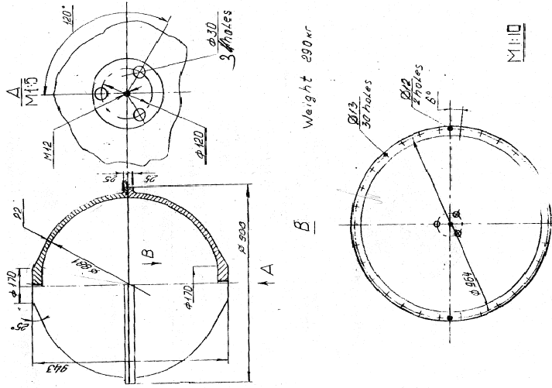

Fig. 1 : titanium spherical caps – original drawing from Russian Academy of sciences.
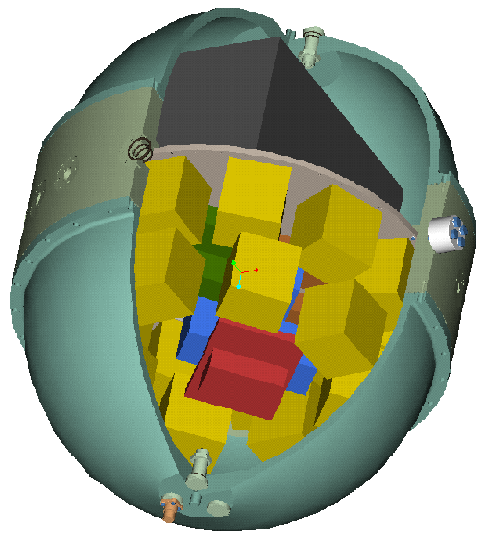

Fig. 2 : layout of the components inside the JB.

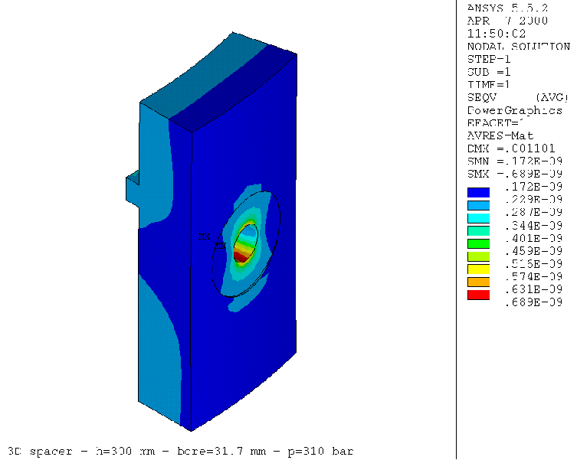
Fig. 3 : FEA analysis of the titanium spacer.
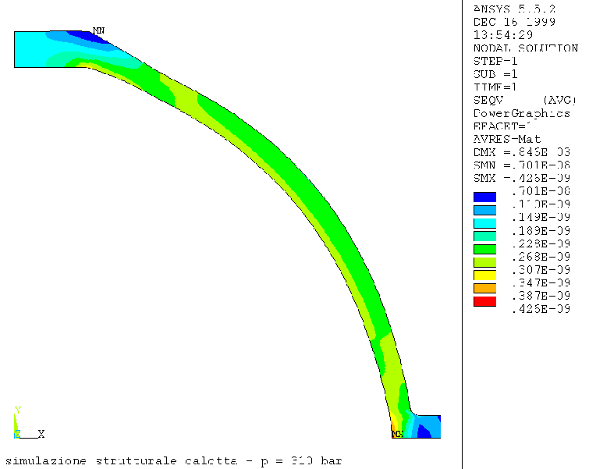
Fig. 4 : FEA analysis of the spherical caps.

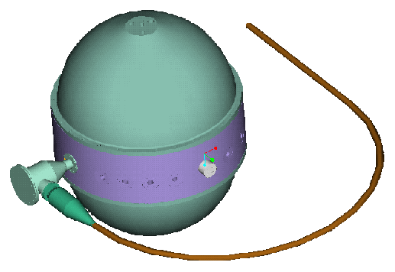

Fig. 5 : JB layout with main cable entry.
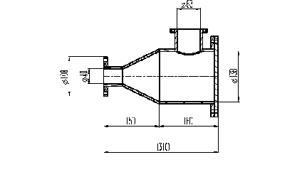

Fig. 6 : intermediate JB cross section (proposal).

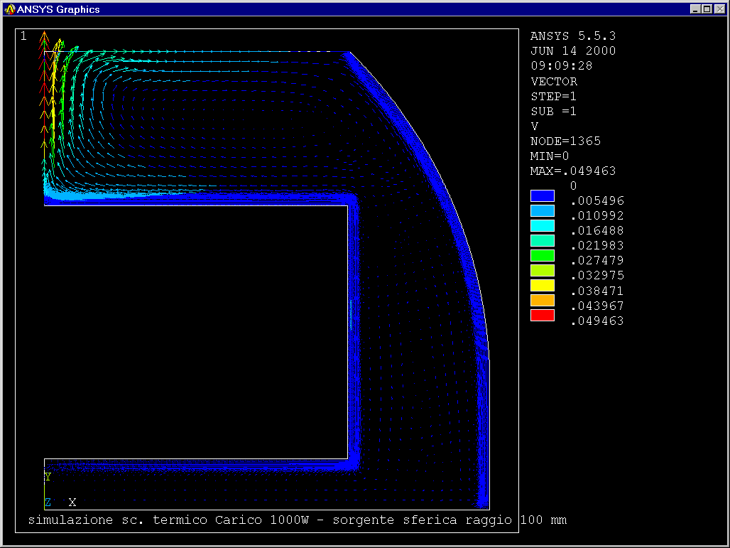

Fig. 7 : velocity distribution [m/s] of the oil inside the vessel – oil in the upper hemisphere

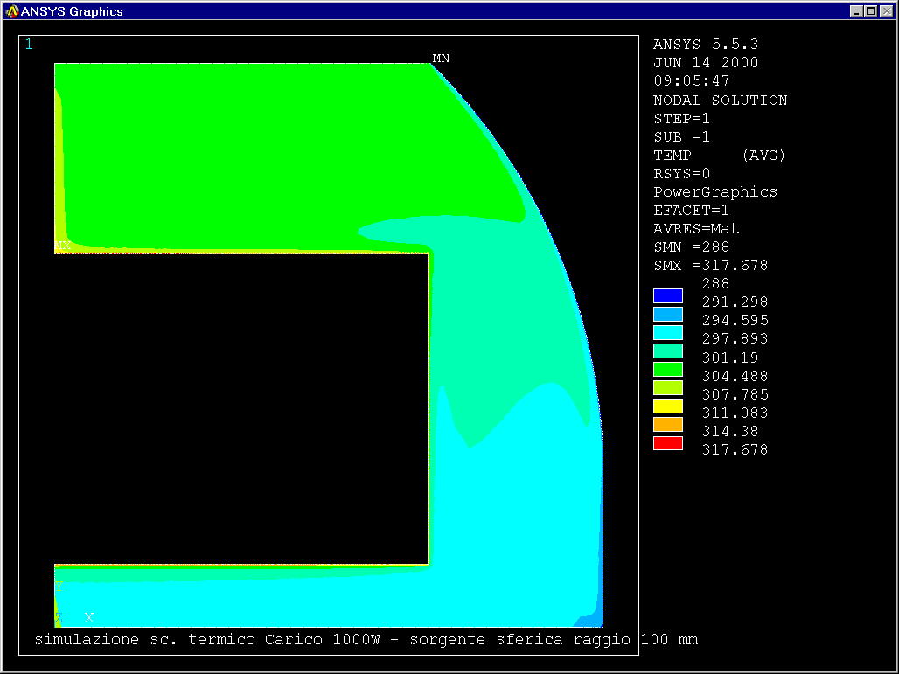

Fig. 8 : temperature distribution [K] of the oil inside the vessel – oil in the upper hemisphere

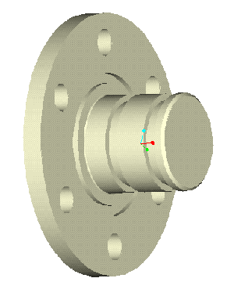

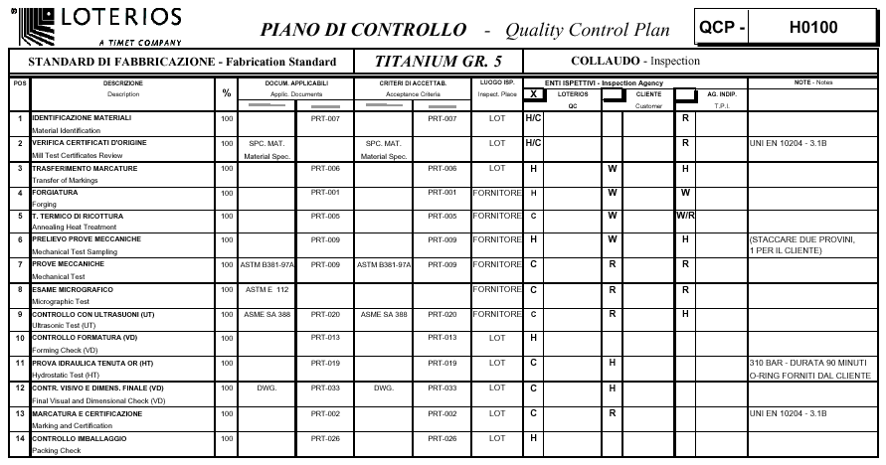
Fig. 9 : dummy penetrator.

Fig. 10 : supplier’s quality control plan.

