Minute of the V Meeting GSI-INFN held in Genova on March 6th 2007

This meeting was a sort of repetition of the meeting held last December. It was aimed to close the first part of the activities aiming to perform feasibility studies and preliminary developments and to move towards the conceptual design.
Due to the changes in the magnet characteristics done by GSI in December, INFN has re-developed a new 2D lay-out, which will be presented today .
The agenda was organized in a way to discuss the relevant points and to get a conclusion for the starting of the conceptual design phase.

Participants:
AS-G R.Marabotto and A.Pellecchia
GSI: J.Kaugerts and G.Moritz
INFN Genova: P.Fabbricatore and S.Farinon
INFN LNF: U.Gambardella
INFN Milano-LASA G.Bellomo, M.Sorbi and G.Volpini

AGENDA
1. Introduction P.Fabbricatore
2.Approval of minutes of last meeting
3. New 2D winding lay-out (field, margins, harmonics,
permanent current effects,..) M.Sorbi
4.Mechanics S.Farinon
5. ASG Sup. analysis of INFN design R.Marabotto
6. Status of conductor developments G.Volpini
7 Next developments All
8. Abstracts submitted to MT20 Al
9. Next meetings (For the next one it is proposed May 29th at GSI)

SUMMARY OF MAIN POINTS

Design parameters. INFN has developed a new preliminary design on the basis of the indications received from GSI in December. The new parameters are:
1. Magnetic Field 4.5 T
2. Effective length of the prototype 3878.5 mm
(exact half length of the main dipole)
3. Bending angle 3 1/3 degree
4. Bending radius 66 2/3 m
5. Allowed maximum slot length 4818.3 mm
6. Free aperture (inner side of the beam pipe) 86 mm
leading to 100 mm coil ID
7. Field quality in 10⁻⁴ units @r= 35 mm (70 % of coil ID)
7.1 Stretcher mode ± 2
7.2 At injection field of 1.6 T ± 2
7.3 At extraction field of 4.5 T ± 2
8. Ramp rate 1 T/s

A debate developed around the field quality. G. Moritz was oriented to restrict the requirement to ± 1 units. On this point GSI will provide a more refined requirement.
The new design as reported in the presentation of M.Sorbi has the following characteristics:
  - Coil Inner Diameter 100 mm
  - Bending radius 66.7 m
  - Number of turns 34
  - Number of blocks 5
  - Cored Conductor (Same dimensions of LHC outer layer)
6.1 Wire Diameter 0.825 mm
6.2 Matrix/Sc ratio 1.8
6.3 Number of strands 36
  - Temperature margin 1 K
  - Thickness of the SS collar 30 mm
(holding all the force)
  - Coil wedges and fillers G11
The identified 2D lay-out came after a long analysis of several configurations. In particular it was found that:
- 3-blocks give no satisfactory solutions.
- 4-blocks: some solutions with 34 turns
- 4-blocks: one solution with 35 turns and 40 strands cable.
Not convenient for higher losses and for constructions worries.
- 5-blocks: no solutions with 35 turns and 36 strands cable
- 5-blocks: solutions with 34 turns

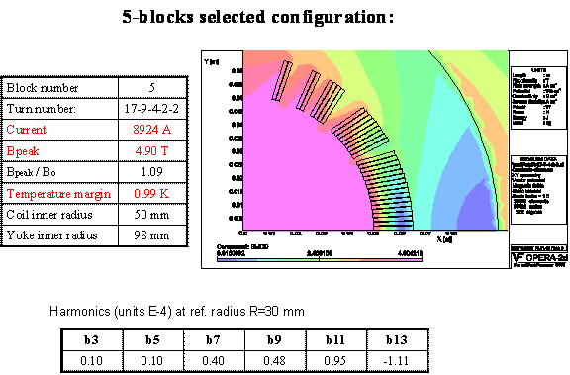

Permanent and coupling currents effects. Ac losses. INFN has devoted a lot of effort aiming to obtain a clear and indubitable information about the effect of field harmonics due to the permanent magnetization currents, the inter-filament coupling currents and the inter-strand coupling currents. Several standard and new methods were involved in this wide range analysis: 1) Through ROXIE code, which provides this information as a standard output; 2) Through OPERA, providing this information after introducing a B-H curve based on the wire magnetization (obtained from classical formulae for the magnetization of a sc wire placed in an external transverse magnetic field, or from some direct magnetization measurement); 3) Through ANSYS code in the same way of previous case; 4) Through ANSYS by overlapping to the transport current in each strands, the magnetization currents depending on the field amplitude and orientation and involving also in this case the classical formulae for the magnetization of a sc wire placed in an external transverse magnetic field, or some direct magnetization measurements; 5) Through a FORTRAN code introducing the magnetization strand by strand and computing the field generated by the magnetic moments. The very interesting result is that all these methods provide results in excellent agreement for harmonics b3 and b5.
Based on the same methods the ac losses in the single strands can be calculated showing also in this case a very good agreement among them and with the Wilson approach integrated in an EXCELL file. The following data were used for the loss evaluation:
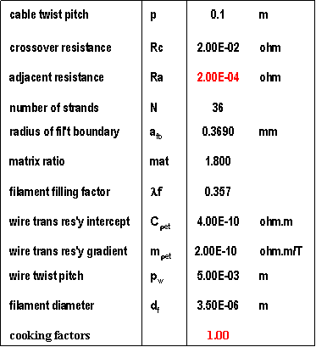

The ac losses were calculated to be in the range 3.5-3.7 W/m, which are a very promising values. On the basis of the knowledge of the power dissipation during a cycle inside the coil (depending on the position) a first evaluation of the maximum temperature increase in the coil has been done resulting in 0.26 K. This temperature variation reduces of 25% the temperature margin and of 40% the minimum propagation energy. The reactions to this result are not unanimous: someone sees the need to increase the cooling capacity, for other this variation still leaves a satisfactory margin. A better thinking is required before to draw a final conclusion.

Mechanics. S: Farinon showed her mechanical analysis based on a 2D mechanical model including coil and collars.
- As first step the collaring is simulated including also the presence of a stainless steel shim placed on the top side of the coil.
- The collared coil is cooled at 4.5 K.
- The magnetic forces, as computed separately, are applied resulting in a deformation of the cold mass.
- The deformed cold mass dimensions are entered as input file for a new magnetic computation giving the harmonic components as function of the magnetic field.

This analysis has been done for several values of the shim thickness. It appeared that the shim thickness should be around 0.3 mm, resulting in an average stress of 40 MPa. The displacements during the energization are limited around 40 μm. The sextupole components resulted to be 6 units (see figure). On this basis a re-optimization of the design shall be carried out
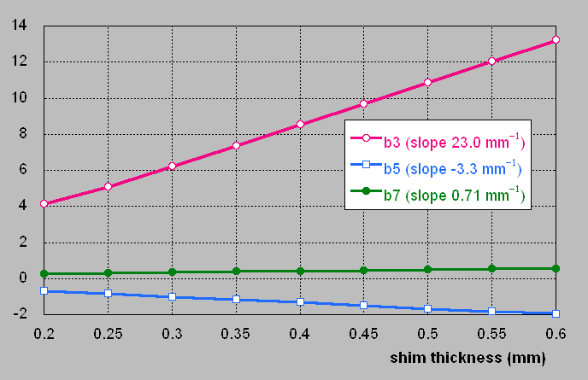

Conductor. G.Volpini gave an update of the conductor development. The order for the practice cable has been awarded to Luvata, who made the best economical offer. The cabling will be subcontracted to New England Electrical Wire, a firm very well experienced in this field. The Request For Quotation process for the real conductor has been postponed to the development of a new design after the change of parameters. Now the process can start again. J.Kaugerts will send to G. Volpini his comments to the specification of the RFQ.
INFN thinks that a special attention shall be paid to the paramagnetic effect of Mn in the Cu matrix. Measurements done in some wires (the Luvata wire obtained by re-stacking 7 strands and the wire SL87969 produced by EAS), showed a strong paramagnetic effect, which can change the harmonic scenario. After some post-meeting investigation the conclusion on this point is that The Mn content in the Cu matrix can give a paramagnetic component to the magnetization, which in principle could affect the harmonics. This effect shall be better understood through measurements on the final wire we will use for SIS300 magnet.

Conclusion

The new INFN design is approved. It is possible now to move toward the conceptual design. Qualified points related to the upcoming activities are:

1 2D Design completion and optimization: (Real iron yoke magnetic properties, re-optimization of harmonics in operating conditions, thermal analysis)
2 End design passing through the use of ROXIE and its assessment through winding tests in ASG Superconductors.

