Points to be discussed between INFN and GSI

1 Introduction

This note introduces the discussion on SIS300 bus bars, diodes and G11CR and quench propagation velocities.

2 Bus bars

The SIS300 dipole ring will have 3 main circuits: one for the dipoles, one for focusing quadrupoles and a last one for defocusing quadrupoles. To keep the field symmetry, it is advisable to have 4 slots for bus bars in the iron just below the He containment cylinder as depicted in Fig. 1. In the HEBT (High Energy Beam transport line), a SIS300 dipole or quadrupole will have from 0 to 4 pairs of bus bars (the 4 slots are therefore needed).

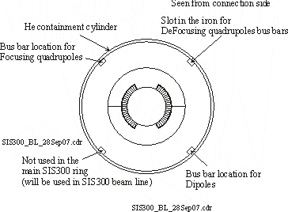

Fig. 1 Schematic of a SIS300 dipole with 4 slots in the iron for bus bars.

In case of quench, the current in the dipole circuit will be dumped with a time constant τ = 4 s (use of 3 dump resistors, see Fig. 2).

Fig. 2 Use of 3 dump resistors when dipoles are equipped with cold diodes.

The temperature of the bus bars should be kept below 250 K (as for LHC). To reach this target, the bus bars must be stabilized (a metal (Cu or brass) must be added to the cable to reduce its temperature). Furthermore, one bus bar must be mechanically reinforced as it travels from one magnet to the next one. For LHC magnets, the copper stabilizer (Fig. 3) fulfills these mechanical and quench protection purposes.
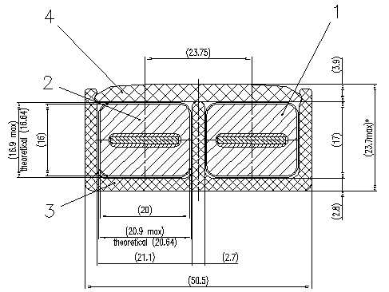
Fig. 3 LHC dipole bus bars.

I would suggest using for SIS300 dipoles and quadrupoles:
- the LHC quadrupoles bus bar (Fig. 4)
- replace Cu for the stabilizer by brass in order to reduce the AC losses

Fig. 4 proposes a sketch for the SIS300 dipole and quadrupole bus bars. They would also use a G11CR structure to insulate them from the iron and He containment cylinder.
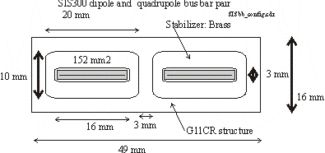
Fig. 4 Proposal for the SIS300 dipole and quadrupole bus bars.

GSI tests facility also uses the LHC quadrupoles bus bars. AC losses were measured on them and calculations (ref 2) were performed with ANSYS to compute the losses in the stabilizer.

2 G11CR

G11CR will be (very probably) used for wedges and end spacers. In fall next year, GSI will irradiate Kapton, G11 and insulated cables up to 30 MGy in conditions close to those in the future facility. This irradiation is heavy: it may require 60*8 h of beam time and will only be done once for the whole FAIR project. We therefore need to accurately define the sample shape and which type of measurement should be done later on.

The wedges will see a load of around 70 MPa. It is very important that INFN defines:
- what type of load the wedges will see (notably during cycling)
- what type of measurement (fatigue, load level) one should apply to the irradiated samples
- what is the proper size of the samples for these measurement

The same question should also be answered for the end spacers. The weakest points in the LHC magnets are the end spacers of the insertion quadrupoles whose life time dose is 20 MGy.

We estimate that these questions should be treated with a high priority in order to get answers in May 2007 (at the latest) so that we have a few more months to ask a company to prepare the G11CR samples with the appropriate shape and materials.

For the ITER project, the coil insulation will use a sandwich material made of Kapton and G11CR. The usual G11CR uses E glass, which contains boron oxide that is radio active. ITER will have its G11CR with S glass (which is 3 times more expensive that E glass). GSI also wants to have its G11CR with S glass. We would like that the 1st SIS300 dipole also uses S glass. Right now, GSI has not determined which epoxy and hardener the G11CR should use, but a PhD student (Tim Seidl) investigates the subject.

3 Cold diodes

The actual quench protection scheme for SIS300 dipoles and quadrupoles uses dump resistors, quench heaters and cold diodes (Fig. 5). D. Hagedorn should send to GSI end in December a quench study on SIS300 dipoles considering cold diodes and the alternative warm bypass. The decision between cold diodes and warm bypass will be difficult to take because:
- we don't know at which dose and neutron flux one LHC diode breaks
- there are no reliable radiation losses calculations for the SIS300 ring

So we have to go on with further diode irradiation and ask for radiation computations. 6 LHC diodes were irradiated in 2006 at ITEP up to 1.3 kGy and 2.25 10¹⁴ neutron/cm² (ref 3).

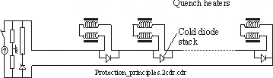
Fig. 5 Schematic of a protection scheme with dump resistor(s), quench heaters and cold diodes.

We can suspect that a diode will be destroyed when its reverse voltage at 300 K reaches zero. By linearly prolonging the reverse voltages recorded in Fig. 6, we can estimate that diodes with annealing will reach zero reverse voltage around 3 10¹⁴ n/cm² when annealed and 4.5 10¹⁴ n/cm² when not annealed.
Fig. 6 Reverse voltage measured at 1 mA at 300 K as a function of fluence.

In October 2006, a new contract amounting 70 kEuros was prepared for an irradiation at ITEP up to 4.5 10¹⁴ n/cm². Because of budget restriction in 2007, we could not sign it. According to me, it is important to go on the irradiation process that could give us the limit at which diodes break. The six irradiated diodes and all the electrical equipment is still at ITEP whose personal knows how to properly measure the diodes.

4 Measurement of quench propagation velocities

From the LHC experience, quench propagation velocities were only measured at 1.9 K on magnets (Fig. 7). Furthermore, the SIS300 cable has a CuMn inter-filamentary matrix that could speed up quench propagation velocities (V_{pf}).

Fig. 7 Quench propagation velocities measured in the outer layer of 2 LHC dipole prototypes (SIS300_D_model_QH.xls).

Fig. 8 presents the approximate position of the quench heaters for SIS300. We should always consider the worst case in which only one out of 2 heater sets fails. In that case, the quench resistance due to the heaters depends on Vpf. If Vpf decreases, then the quen ch heaters must be wider to keep the necessary quench resistance. Wider heaters means more current in the heaters, more voltage and energy in the capacitors. That's why is important to measure Vpf. This could be done at Fresca. Furthermore, we could measure the magneto-resistance (of prime importance to compute the hotspot temperature) of the cable up to 6 T.
A last important argument: if INFN intents to make quench calculations with ANSYS, the most important validation is to have the same Vpf than that measured on short samples.

Fig. 8 Approximate position of the quench heaters for SIS300.

The following input parameters of the quench study should be measured as soon as possible:
- the linear resistance of the strands at 10 K, 77K and 300 K
- the resistivity of CuMn on a pure CuMn strand at 10 K, 77K and 300 K

references

ref 1 E. Floch. "SIS300 HEBT, Preliminary design of the bus bar connections". GSI internal note MT-INT-ErF-2007-009 , October 2007.

ref 2 S. Y. Shim. " Stabilizer Eddy Loss of SIS300 Bus Bar". GSI internal note: MT-INT-SYS-2007-004 24.09.2007.

ref 3 E. Floch. " Diode irradiation at ITEP, March 2006". GSI Internal Note: MT-INT-ErF-2006-010 19.04.2006
ref 4

This document: SIS300D_busbar_diodes_G11CR.doc

