Abstract— At present, one of the main options for beam bending dipoles of the SIS 300 synchrotron, under design for the FAIR facility at GSI, is a single layer magnet 7.8 m long, 100 mm in bore diameter, generating 4.5 T. This coil has two main features: it is curved, with a curvature radius of 66.67 m (the corresponding sagitta is 114 mm), and shall be ramped at 1 T/s. Both these characteristics demand challenging R&D, aimed at the development of the required conductor and winding technology. The paper discusses both these aspects, in the frame of a general ongoing R&D program at INFN, under the name DISCORAP. Its goal is the construction of a short prototype (3.8 m) dipole, fully integrated into its horizontal cryostat, within three years. The R&D program includes: 1) the activities required to develop low loss superconducting wires and cable; 2) the technological developments (at the industrial level) for defining and optimizing the dipole constructing methods; 3) the construction of curved dipole coil winding models; 4) the construction of the complete curved dipole; 5) the test of the curved dipole in a vertical cryostat; 6) the integration of the curved dipole into a horizontal cryostat, for the final test at GSI.
Development of a Curved Fast Ramped Dipole for FAIR SIS300
P.Fabbricatore, F. Alessandria, G. Bellomo, S. Farinon, U. Gambardella , J.Kaugerts, R.Marabotto, R.Musenich, G.Moritz, M. Sorbi, and G. Volpini
Index Terms — Superconducting dipoles, fast ramped magnets.

Introduction
In the framework of a large international collaboration it is planned to construct a new accelerator complex FAIR [1], which will be integrated in the existing GSI facility in Darmstadt and will provide high intensity primary and secondary beams of ions and antiprotons for experiments in nuclear, atomic and plasma physics. The heart of the FAIR facility is the synchrotron SIS100 (100 Tm rigidity), which will accelerate ions and protons at a high repetition rate and send them to either the targets for Radioactive Ion Beam (RIB) or Antiproton Beam production or the SIS300 (300 Tm rigidity) synchrotron, for further acceleration to higher energies (90 GeV protons). In order to reach the required high intensities, the magnets of the synchrotrons [2] have to be rapidly pulsed at a high repetition frequency. The required dipole ramp rate is 4 T/s for SIS100 at about 1 Hz and 1 T/s for SIS300, with a duty cycle of 50%. This paper deals with R&D activities aimed at developing the high field rapidly-cycling super-conducting dipoles needed for SIS300. At an early stage of the FAIR facility design, the beam rigidity of the synchrotron placed after the SIS100 was 200 Tm. This rigidity was obtained through superconducting dipoles of 2.9 m magnetic length, generating a 4 T field in 86 mm aperture. During the R&D phase, it was decided to increase the beam rigidity of this second synchrotron to 300 Tm, the dipole aperture field to 6 T, and in addition the inner coil diameter to 100 mm. IHEP, Protvino, prepared a Conceptual Design Report on the basis of the UNK dipole [3]. The two-layer coil (based on LHC dipole outer layer cable with stainless steel core) was designed to be cooled with supercritical helium, re-cooled by two-phase helium within the magnet. In a later stage of the SIS300 design, it was stressed the importance to enlarge the acceptance at a minimum field volume. Consequently, a curved design with a radius of 66.67 m was proposed. The parameters are given in Table I. This coil has two main features: it is curved (the corresponding sagitta is 114 mm), and shall be ramped at 1 T/s. Both these characteristics demanded for a challenging R&D, aimed at the development of the required low loss conductor and a suitable winding technology. As first step, in order to check if show-stoppers could arise at constructive level, technical feasibility studies were performed involving experienced companies. The positive answer coming from these studies together with the promising result of the cost estimates (potential cost save with respect to the 6 T straight magnet) gave 'green light' for further design work by the Italian National Institute of Nuclear Physics (INFN) in the framework of a project called DISCORAP (“Dipoli SuperCOnduttori RApidamente Pulsati”), started in 2006. The geometry of the Rutherford cable for this magnet is the same as that used for the 6 T straight model. Coil winding models with a curved mandrel will be built. A half-length magnet will be ready for testing in 2009. The present paper mainly discusses the design choices, which provided the guideline for the development of the curved fast ramped superconducting dipole presently under way. The status of the design activities is discussed as well, stressing the aspects related to the ac losses, the thermal stability, the mechanical aspects involved in a magnet to be cycled 10⁶ times and the manufacturing problems to be faced.

TABLE I
Main parameters of the curved DIPOLE option FOR siS300
Magnetic Field | 4.5 T
Magnetic length | 7757 mm
Bending angle | 6º 2/3
Bending radius | 66.667 m
Free aperture (ID of the beam pipe) | 86 mm
Coil inner diameter | 100 mm
Field quality at radius R=35 mm | 2 (in 10⁻⁴ units)
Ramp rate | 1 T/s

Basic Design Choices
Since the beginning of the R&D activity, preliminary to the engineering design, it was clear that one of the main problems to be solved was the technical feasibility of a cos-theta curved magnet. In this frame two interconnected aspects were relevant: a) the definition of a credible and robust manufacturing method for a curved magnet; b) the development of a magnet design, which minimized the difficulties of the manufacture. These two aspects were investigated in parallel by developing a preliminary design, which provided the suitable input to experienced companies, asked to study the possible manufacturing methods.
This process was quite complex with many feedbacks between design and feasibility analyses. Here we summarise the main results in terms of coil layout and preferential manufacturing method. The preliminary design activities had to face two other very important aspects. The first one is of mechanical nature, since the magnet has to support 10⁶ magnetic cycles. The second one is related to the need to limit the coil heating and remove efficiently the heat dissipation. While the mechanical and the heat exchange problematic are related to the winding and consequently are discussed in detail here, the aspects of the heat dissipation are more related to the conductor design and are only briefly recalled, referring to other papers dedicated to this topic [4,5].

Basic coil layout
Our starting assumption was that the coil should be curved since the winding, because: 1) This solutions allows defining without uncertainty the geometrical dimensions of a curved stress-free coil; 2) Once cured, the coil can be handled in simple and safe way for the following manufacturing operations (collaring, insertion in the iron yoke, …).
A different solution involving the bending of a straight coil has to face the problem of spring back effects during all manufacturing stages and coil operation. In fact, considering a coil outer radius around 65.4 mm (50 mm inner radius + 15.4 mm of conductor radial thickness and insulation), the bending strain for obtaining a curvature of 66.67 m is about 10⁻³. This value is too high when considering both the control of the coil geometry during the collaring and possible shear failures of cable-to-cable insulation.
The choice of a curved winding naturally oriented, on the design side, to a single layer coil mechanically supported only by the collars. These important choices are based on the reason that the mechanical coupling between two curved layers or between a curved collared coil and a curved yoke appeared to be critical operations, which could be afforded only once the simplest curved layout (single collared layer) had been deeply investigated. We were helped in moving to this direction by the relatively low value of the field (4.5 T), obtainable involving one layer only. Furthermore, the magnetic forces are not significantly high to require a mechanical role of the yoke. Had been the field a little higher (5 T), this path along design choices would have become impossible to be gone through.

Target of the R&D program
With the idea to develop a robust design of a single layer curved dipole for SIS300, the objectives of the dedicated R&D program DISCORAP were defined as: 1) Development of a low loss conductor with a staged approach, enabling to have available in very short time some lengths of cored dummy cable for winding tests, in a relatively longer time a cable with minimal characteristics, and later on a cable with optimal properties with relation to ac losses [5]; 2) Study and development of the winding technologies for curved cos-theta dipoles, to be assessed by the construction of model coils (foreseen to be completed at beginning of 2008) using the dummy cable; 3) Construction of the cold mass (collared coil plus yoke) of a short prototype (3878.5 mm), to be tested in a LHe bath using a vertical cryostat; 4) Integration of the cold mass in a horizontal cryostat within 2009; 5) Test of the prototype at GSI. In fact the choice to construct a prototype having half magnetic length is not only due to the need to reduce the risk of the R&D activities, but also to the fact that the SIS300 FODO lattice includes half length magnets. So in principle the prototype under development is in fact a magnet of the synchrotron.

The Conductor
The conductor under development [5] is based on a cored Rutherford cable with 36 strands (similar to the LHC outer layer), whose main characteristics are shown in Table II. This conductor is characterized by having several components sized for low ac losses: 1) The filaments are fine (down to 2.5 μm) for minimizing the hysteretic losses; 2) The part of the matrix surrounding the filaments is made of CuMn, for the electromagnetic decoupling of the filaments and for increasing the transverse resistivity and, consequently, the coupling losses; 3) The cable is cored using a thin stainless steel foil (25 μm) for cutting down the inter-strand coupling currents. The contribution to ac losses in the magnet (in Watt per magnet unit length), due to the conductor, ranges from 4.4 W/m at 1.5 T to 2.7 W/m at 4.5 T [6]. This conductor is basically the one already defined as target for the 6T straight option. We started the design of our curved dipole using the same conductor, for the main reason to minimize the costs of the conductor R&D. After some magnetic, mechanical and thermal analyses we confirmed this choice. According to the developed lay-out the peak field in the winding is 4.9 T and the magnet is working at 69% of the critical current on the load line. The corresponding current sharing temperature is 5.69 K, which is about 1 K higher than the maximum temperature of the supercritical helium, cooling the magnet (4.7 K).

TABLE II
Main Parameters of thE sUPERCONDUCTING cABLE
Strand characteristics :
Filament diameter | 2.5 to 3.5 μm
Strand Diameter | 0.825 mm
Twist Pitch | 5 mm
Cable characteristics :
Number of strands | 36
Width | 15.1 mm
Thickness: Thin/Thick edges | 1.362 mm/ 1.598 mm
Core material/thickness | AISI 304/ 25 μm
Critical Current @5T , 4.22K | >18540 A
We considered this margin a good starting point, to be confirmed later by thermal analyses involving the heat exchange problematic. At the same time we verified that a higher temperature margin would require either a greater number of strands in the cable or the switching to a two layer solution. Both these consequences were considered not acceptable because the two layer option had been already canceled for manufacturing reasons, while a larger (radially) conductor was considered risky for possible instable behavior during the winding. However a 40 strand cable, with the same wire, only increases the margin of 0.1 K.

Main Design Issues

Magnetic layout and field quality
Based on the guidelines described in the previous section, a deep analysis and optimization activity has been carried out to obtain a configuration with good field quality and maximum temperature margin [6]. A solution with 5 blocks has resulted from these studies, with parameters reported in Table III. The cross section of the coil with the magnetic field distribution for a central field of 4.5 T is shown in Fig.1.
The magnet is not yet fully optimized with respect to the field quality because the saturation effects of the iron yoke are still missing. However, the most important effects on field quality (namely the sextupole and decapole field harmonics), due the ac operation, were studied in many details. There is a contribution to the sextupole coming from the persistent current in the superconducting filament, which is by far the most important: it ranges from -3.65 units in 10⁻⁴ at 0.5 T down to 0.13 units at full field. The decapole is one order of magnitude lower. The inter-filament and inter-strand coupling currents are also less affecting the field quality, being both in the order of tenth of unit.

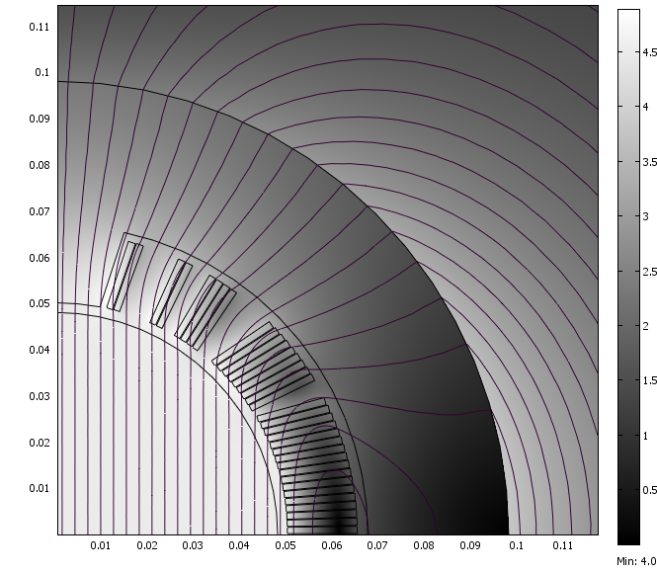

Fig.1 Coil cross section (the scale is in m) with field distribution and equipotential lines at the peak current of 9824 A (Comsol© output). The peak field (4.91 T) is found at both the two blocks closer to the pole (the upper ones in the figure made of two turns).

TABLE III
Main Parameters of the optimized solution (μ iron- = ∞))
Block number | 5
Turn number/quadrant | 34 (17+9+4+2+2)
Operating current | 8924 A
Yoke inner radius | 98 mm
Peak field on conductor (with self field) | 4.90 T
Bpeak / Bo | 1.09
Working point on load line | 69%
Current sharing temperature | 5.69 K

Materials and Components
The choice of the materials involved in the magnet was done in view to limit the ac losses and to optimize the field quality.
The coil wedges and the end spacers are in G11, so to cut down the eddy currents during the ramps. Ceramic materials were also considered as a potential interesting solution, but the worry for possible conductor damages (ceramic materials are generally hard and brittle) led to leave aside this option, to be considered in future developments. Some reservations are related to the radiation hardness. At present the available information about the radiation load in the dipole volume has confirmed that G11 is acceptable from this point of view.
The collar material was chosen on the basis of the required mechanical and magnetic properties. The preliminary mechanical analysis showed that during the field ramp the peak Von Mises stress in the collar could be as high as 400 MPa. This stress level demands for a high strength material, also in view of the fatigue load. At the same time the relative magnetic permeability is required to be less than 1.003 to keep the field quality perturbation at the level of 0.1 units in the field region from 0.5 T (stretcher mode) to 4.5 T. Several austenitic steels with a significant Mn content were investigated in the past by laboratories developing accelerator dipole magnets. We took advantages from these studies [7] and selected the Nitronic 40, which has a yield stress R_{0.2} ranging from 700 MPa at room temperature up to 1400 MPa at 4.2 K. The thermal contraction of this alloy is 2.3‰, which, though far from the winding contraction in the azimuthal direction (around 6 ‰), is still compatible with an acceptable level of the required pre-stress during collaring (70 MPa), for having a coil with a residual pre-stress of 50 MPa in operating conditions. The radial thickness of the collars has been not yet frozen. All calculations reported in this paper are related to a thickness of 30 mm. We are considering a reduction down to 25 mm (compatibly with mechanical requirements) for enhancing the role of the magnetic yoke so decreasing the current with the consequence to increase the stability margin. The collars are axially laminated to a thickness of 3 mm. In fact the ac losses due to the eddy currents would allow a larger thickness, but the envisaged construction methods (punching of thin sheaths) put a limit to the allowed thickness.
The cable insulation is made of three polyimide layers forming a total half-thickness, after curing and under 50 MPa stress, of 125 μm. Since the cooling of the coil is done through supercritical helium in contact with the coil inner wall, the temperature of the cable is greatly determined by the balance between the heat dissipation and the heat removal through this thin insulation layer.
A thermal analysis in steady state conditions demonstrated that the temperature in the winding can increase up to 0.3 K with respect to the coolant temperature. Computations under more realistic assumptions (transient phenomenology) have shown that the temperature increase could be lower (0.2 K). This study is not yet completed because the heat ex-change problematic was not completely integrated in the simulation. This point will need future efforts not only in simulations but also though experimental activities. We remind here that the excellent results obtained on the first and unique prototype of SIS300 [8] (the GSI001, which was rather a model coil for ac studies operated up to 4 T/s), might be due to the holes in the insulation ensuring an optimum cooling. We do not intend to make holes in the insulation for the risks connected to sparks during quenches, consequently the limits in the heat removals shall be deeply understood.
The material for yoke lamination has been investigated with the main aim to have low ac losses, here coming from three contributions: hysteretic, eddy currents and anomalous losses. At the same time, a commercially available product was searched. In this framework only electrical steel with silicon can be considered. It can be easily verified that at the used ramp rates the main contribution to the losses is coming from the magnetic hysteresis, so we looked for silicon steel having a coercitive field as low as possible. Since the coercitive field is a decreasing function of the Si content, one would use a high Si alloy. Unfortunately also the brittleness is increasing with the Si content. A good compromise was found for a Si content of 3.5% giving a coercitive field of 35 A/m. We identified the commercial lamination M600-100A, according the EN 10106 code (1995). The calculated losses in the magnet involving this material are 1.3 W/m.

3D Layout
At present a first 3D-layout has been developed including the coil ends. Fig.2 shows as the coil should appear. It can be noticed that the collars under design are very similar to the ones involved in SSC main dipoles. Though many details are not visible. they are parallel packed in groups of 16 (for a total axial thickness of 50 mm), placed in a way to follow the coil curvature through the introduction of thin spacers (0.8 mm) placed only in one side of the midplane (the one corresponding to the convex part).
The ground insulation has been sized following LHC main dipole design. It includes channels for supercritical He, providing an additional cooling (other than the one trough the inner surface) and (possibly) quench heaters.
These choices are not yet frozen, being a series of 3D magnetic, mechanical and thermal analyses still under way. The target is to finish the most of design activities within the spring 2008. .
An important intermediate milestone is the industrial assessment of the winding technology for a curve cos-theta dipole, through the construction of cured curved poles within February 2008.
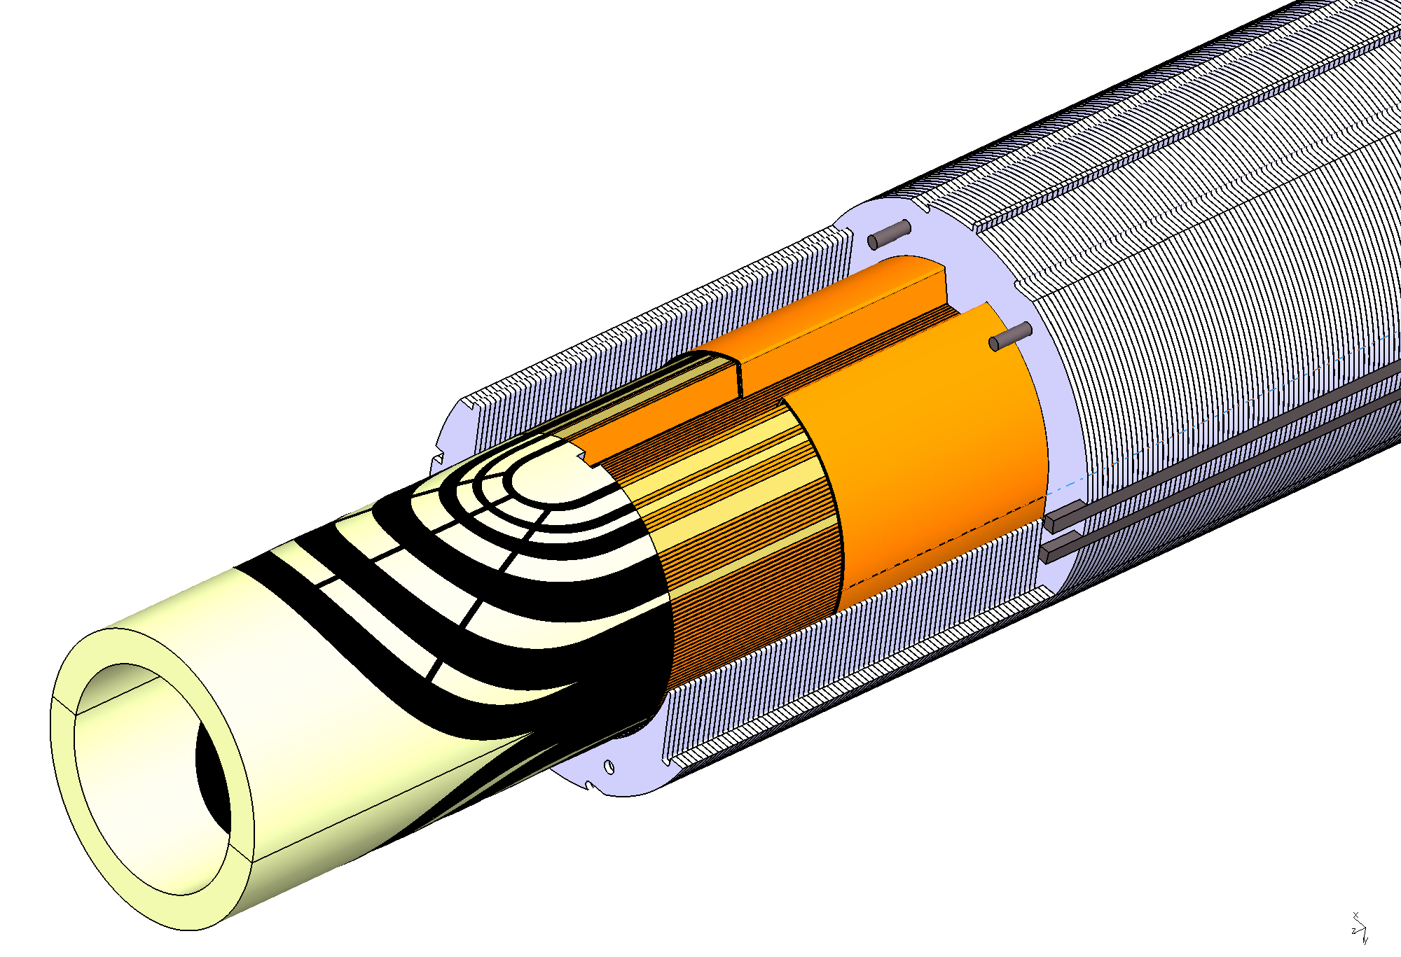

Fig.2 Detail of the present coil end design. Coil ground insulation and collar structure is also shown.

Conclusions
Design activities coupled with conductor and model coil developments are under way for developing a curved fast cycled superconducting dipole suitable for operations of the SIS300 synchrotron at FAIR. The main target is the construction within 2009 of a prototype magnet (cold mass fully integrated in a horizontal cryostat), which will be tested at GSI. The need of using non-conventional tools (to be completely developed) makes critical the achievements of this goal. Other crucial aspects of the R&D are related to the development of a low loss conductor, generating about 3.5 W per magnet unit length, and to the demonstration that the heat dissipated in the winding can be efficiently removed through the cooling of the dipole inner surface.

References
- W. F. Henning, “The GSI project: An international facility for ions and antiprotons”,.Nuclear physics A, Nuclear ad hadronic physics 734, 654-660, 2004
- Moritz G, “Superconducting magnets, for the International accelerator facility for beams of ions and antiprotons at GSI” IEEE Trans on App Supercon 13 (2): 1329-1334, 2003.
- J.E.Kaugerts, G.Moritz, C. Muehle,A. Ageev, I.O. Bogdanov, S.- Kozub, P. Shcherbakov, V. Sytnik, V., L. Tkachenko, V. Zubko, D. Tommasini, M.N. Wilson, W. Hassenzahl, “Design of a 6 T, 1T/s fast-ramping synchrotron magnet for GSI’s planned SIS 300 accelerator”, IEEE Trans on App Supercon 15(2), 1225–1227, 2005
- P. Fabbricatore P, Farinon S, Gambardella U, and G.Volpini, “Rapid cycling superconducting magnets” NUCLEAR PHYSICS B-154: 157-162, 2006
- M. Sorbi, F. Alessandria, G. Bellomo, P. Fabbricatore, S. Farinon, U. Gambardella and G. Volpini “Field Quality and Losses for the 4.5 T Superconducting Pulsed Dipole of SIS300” contributed paper to Magnet Technology MT-20.
- G. Volpini, F. Alessandria, G. Bellomo, P. Fabbricatore, S. Farinon, U. Gambardella, M. Sorbi, “Low-loss NbTi Rutherford Cable for Application to the Development of SIS-300 Dipoles,” contributed paper to Magnet Technology MT-20.
- C. Lanza and D. Perini, “Characteristics of the Austenitic Steels Used in the LHC Main Dipoles”, IEEE Trans on App Supercon, 12, (1),1252-1255, 2002.
- M.N. Wilson, M .Anerella, G. Ganetis, A.K. Ghosh, P. Joshi, A. Marone, C. Muehle, J. Muratore, J. Schmalzle, R. Soika, R. Thomas, P. Wanderer, J. Kaugerts, G. Moritz, W.V. Hassenzahl, “Measured and calculated losses in model dipole for GSI's heavy ion synchrotron” IEEE Trans on App Supercon,, 14, (2), 306-309,2004

 Manuscript received August 28, 2007. P. Fabbricatore and S. Farinon are with INFN Sez. di Genova, via Dodecaneso 33, 16146 Genova, Italy (e-mail pasquale.fabbricatore@ge.infn.it), tel +390103536340, fax +390103536573 U. Gambardella is with INFN L.N.F., via Fermi 40, Frascati, Italy. F. Alessandria, G. Bellomo, M. Sorbi and G. Volpini are with INFN-LASA and Milan University, Physics Department, via Fratelli Cervi, 201, 20090 Segrate (MI), Italy J.Kaugerts and G.Moritz are with GSI (D) R.Marabotto is with ASG Superconductors, Corso Perrone, Genova (I)

