GSI Fast-Pulsed Synchrotron Project:
MNW Report GSI 15 version 1
1 June 03

Magnetization of Ultra Fine Filament Wires

1. Introduction
The note analyzes the magnetization measurements made at the Universities of Twente and Vienna. By assessing the magnetization at different twist pitches and by comparing the measured magnetization with that calculated from transport critical current density measurement, it attempts to draw some conclusions about
- proximity coupling
- filament distortion
- the reduction of ac loss to be expected in a SIS200 dipole.

2. The Wire Samples
Table 1 lists the wire samples used. The two fine filament wires were tested with different twist pitches in order to bring out the effect of proximity coupling; sample 2A212 was also tested with the matrix etched away for the same reason. Cable 001 wire was chosen for comparison because its magnetization had been measured earlier up to 4T. Figs 1-3 show the cross sections of each wire.

Table 1: The Wire Samples
Manufacturer | Vac | Vac | Oxford
Mfr code | 2A212 | 3N7 | 91-0-80122A-05
description | double stack | single stack | single stack RHIC from cable 001
wire dia | 0.53mm | 0.42mm | 0.641mm
filament dia | 3.4μm | 3.4μm | 5.71μm
number of filaments | 8670 | 6264 | 3580
matrix : filament ratio | 1.65 | 1.25 | 2.25
Nb barrier: filament ratio | 0.04 | 0.04 | 0.04
samples tested | 4mm twist  6mm twist  8mm twist  etched | 3mm twist  3mm 'M' twist  5mm twist  8mm twist | 4mm twist

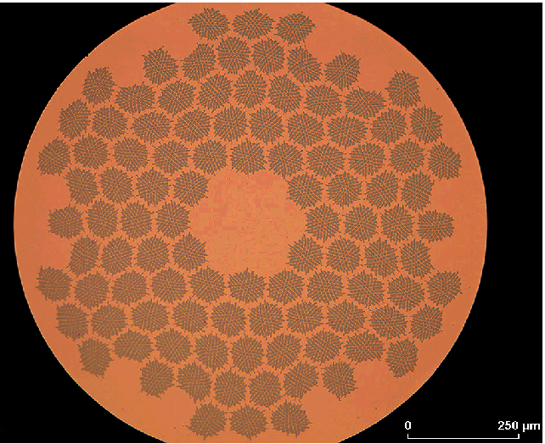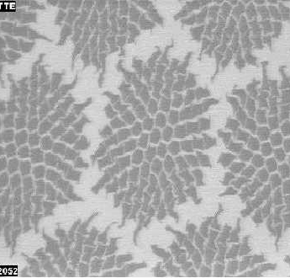
Fig 1: Cross section of Vac wire 2A212, with magnified view
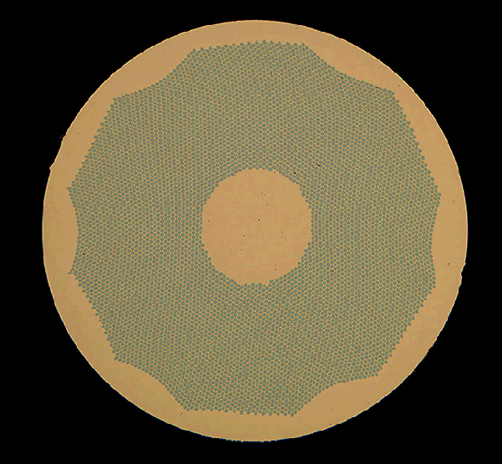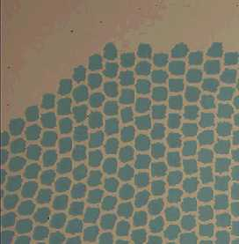
Fig 2: Cross section of Vac wire 3N7, with magnified view
Fig 3: Cross section of Cable 001 wire, 91-0-80122A-05
3. The Measured Data
Magnetization was measured at the universities of Twente and Vienna. I checked one pair of measurements to see that they are consistent but, apart from this, I have used only the Twente measurements because they are more complete and because I need to compare them with cable 001, which was also measured at Twente. Transport critical current density was measured at Vac and at BNL, but only BNL has measured all 3 samples so, after comparing the Vac and BNL J_{c}, I have used the BNL values. Table 2 lists the sources of all data used.
Table 2: Sources of Data
Manufacturer | Vac | Vac |  |  | Oxford
Mfr code | 2A212 | 3N7 |  |  | 91-0-80122A-05
 | magnetization data
measured by | Twente | Twente |  |  | Twente
spreadsheet | VACMAG1.xls | VACSLO.xls |  |  | GSI4-4T.xls
supplied by | email Juris 26 Mar 03 | email Juris 26 Mar 03 |  |  | email Andries 16 Sep 01
measured by | Vienna
spreadsheet | Messdaten MNW.xls
supplied by | email Juris 30 Jan 03
 | transport critical current data
measured by | BNL | BNL |  |  | BNL
spreadsheet | Run 2173.xls | Run 2173.xls |  |  | 91-O-080122-A-05.xls
supplied by | email Arup 7 May 03 | email Arup 7 May 03 |  |  | email Arup 29 Apr 03
measured by | Vac | Vac
spreadsheet | jcvsB.pdf | jcvsB.pdf
supplied by | email Juris 6 May 03 | email Juris 6 May 03

4. Comparison between Measurements at Vienna and Twente
Appendices 1-3 list the magnetization data reduced from the original spreadsheets. Because these sheets contain so much data (up to 10,000 lines), I have used the Excel 'Index' command to pick out a reduced number of lines, including those closest to B=0.1T, 0.2T……..0.9T (and higher fields for wire 91-0-80122A-05). This reduced data was then copied into the attached appendices.
Turning to Appendix 1 (sheet 'magnet sum'ry'), I have adopted the same analysis method for all the magnetization measurements. Firstly I summarize the magnetization in each of the 4 quadrants M ₊ ₋ etc at intervals of 0.1T, then I calculate the mean magnetization for the 2 quadrants where the field is increasing M_{inc} and similarly for the 2 quadrants where the field is decreasing M_{dec}. These two values differ slightly, by the reversible magnetization of NbTi. Next I take the mean M_{mean} of these values to get the irreversible magnetization and then subtract the rate dependent term to get the hysteretic component M_{hyst}. The rate dependent term is taken from the Vienna measurements at different sweep rates, scaled by the square of the twist pitch. Finally I divide by the fill factor λ to get the magnetization M_{NbTi} per unit volume of NbTi. Unless stated otherwise, for the rest of this report, 'magnetization' will mean M_{NbTi} per unit volume of NbTi. Note that, in calculating λ, I subtract the 4% of filament area which is occupied by the pure Nb sheath to get the fill factor for NbTi alone.
I start by comparing the Vienna and Twente measurements. Table 3 and Fig 4 show the result for wire 2A212T4, which had a 4mm twist pitch.
Table 3: Magnetization of 2A212T4 measured at Vienna and Twente (μ_{o}M in Tesla)
B | 0.1 | 0.2 | 0.3 | 0.4 | 0.5 | 0.6 | 0.7 | 0.8 | 0.9
Vienna: M_{NbTi} | 0.0505 | 0.0288 | 0.0211 | 0.0170 | 0.0145 | 0.0128 | 0.0116 | 0.0107 | 0.0098
Twente: M_{NbTi} | 0.0452 | 0.0265 | 0.0195 | 0.0159 | 0.0135 | 0.0120 | 0.0109 | 0.0100 | 0.0093
(M_{Vi}-M_{Tw})/M_{Tw} | 11.7% | 8.9% | 8.2% | 7.1% | 7.4% | 6.5% | 6.5% | 6.7% | 6.3%

Fig 4: Magnetization M_{NbTi} of 2A212T4 measured at Vienna and Twente.

It may be seen from Table 3 that the Vienna measurements are ~ 6.5% higher than Twente at the higher fields, presumable due to a difference in magnetometer calibration. At low fields the difference is higher and the Vienna peaks occur at fields which are more displaced from zero - I have no explanation for this.
Having established that the results are broadly similar, for the rest of this report I will use only the Twente measurements because they cover more wires. Rate dependent terms in all cases are taken from the Vienna 2A212 measurement, but this is always a small correction.

5. Proximity Magnetization.
First, a look at proximity coupling. Fig 5 shows the magnetization of 2A212 as a function of twist pitch. Also shown is the magnetization of an etched sample, ie zero proximity coupling. It may be seen that proximity coupling is negligible at fields above ~0.6T. To get the proximity component we simply subtract the etched magnetization. Unfortunately this magnetization is slightly higher than the un-etched value at higher fields - clearly a calibration error of some kind. I therefore scale the etched magnetization to be the same as un-etched at high field.
Fig 5: Magnetization M_{NbTi} of 2A212 at various twist pitches and etched

Fig 6 shows the proximity magnetization (estimated by subtracting the scaled etched magnetization) versus the twist pitch. It shows roughly the expected linear dependence and extrapolates roughly to zero at zero twist pitch, except at zero field - which I don't understand.
Fig 6: Estimated proximity magnetization of 2A212 versus twist pitch (dashed lines show linear extrapolation)
Finally, Fig 7: shows the proximity magnetization versus field for the 4mm twist sample. In order to use this data in the ac loss calculations of section 7, I have fitted it with:
using the values: M_{p1} = 52.6 mT, k₁ = 11 T⁻¹, M_{p2} = 2.7 mT, k₂ = 2.7 T⁻¹.
Fig 7: Proximity magnetization of 2A212T4 (4mm twist)

Turning now to the single stack composite 3N7, Fig 8 shows the raw magnetization data, ie no correction for rate dependence or fill factor. There is a strange distortion in the shape of the 8mm twist data which I do not understand. There are two samples with 3mm twist pitch: 3N7TM3 was twisted manually and 3N7T3 was twisted on the machine.
Fig 8: Raw magnetization data for sample 3N7
Processing this data as described above, I find the irreversible magnetization curves shown in Fig 9. Plotting the magnetization versus twist pitch in Fig 10 shows roughly the expected straight line. In Appendix 15-2, I have used the extrapolated intercept at zero twist pitch to estimate the proximity coupling, but the accuracy is poor, especially at low field. At least it allows us to say that there is no substantial proximity effect above B ~ 0.6T
Fig 9: Irreversible magnetization of wire sample 3N7 for different twist pitches.

Fig 10: Irreversible magnetization of wire sample 3N7 versus twist pitch for different fields.
Finally, as set out in Appendix 15-3, the magnetization of wire sample 91-0-80122A-05, which was the wire used in GSI cable 001. This was only measured at one twist pitch and there is no etched result, so we have no data on proximity coupling, but at this size it is likely to be very small.

5. Critical Current density
For the two fine filament wires, J_{c} was measured at Vac and BNL. At low fields, the self field of the wire (due to the current it is carrying) can be comparable to or even larger than the externally applied field - so we need to correct for it. The usual correction is to add the peak self field to the external field, which surely over-estimates the effect. An exact correction would involve an integration of the self field over the wire cross section, taking account of the variation of J_{c} with field. Because J_{c} varies very rapidly with field at low fields, such calculations must be iterative and can be quite complex. As a compromise, I add the mean self field calculated assuming a constant J_{c}. Appendix 15-4 gives details of the calculation. For a wire where the outer ring of filaments is at radius 'b' and with a copper centre region of radius 'a', I find the mean self field

Fig 11 shows the corrected J_{c} for wire 2A212. The two measurements use different detection criteria to define the onset of criticality: at BNL it was 10⁻¹⁴ Ωm and at Vac it was 0.1 μV/cm, which corresponds to ~ 3x10⁻¹⁵ Ωm at low fields. Thus the Vac data is generally lower than the BNL data. I don't think either criterion is more 'correct' than the other, but as only BNL has measured all 3 wires, I use this data, which is plotted for all three wires in Fig 12.

Fig 11: Critical current density of wire 2A212, after applying self field correction.

In order to calculate magnetization at arbitrary fields, I need to fit the data. The fit shown is to:

It is done by least squares using the Excel solve function, the coefficients are listed in the Appendices. For use in later ac loss calculations, the fit for cable 001 has 'n' constrained to be 1.0.
Fig 12: Critical current density all wires measured at BNL, after applying self field correction

6. Magnetization Calculated from Critical Current density
Finally, I use the measured J_{c} to calculate the magnetization of cylindrical filaments. Comparing this value with the measured magnetization should give an indication of how circular the filaments actually are. Magnetization is calculated from the usual formula:
Details are given in the Appendices and summarized in Table 4, together with the measured magnetization. For magnetization, I take my best estimate of zero proximity effect, from the etched sample for 2A212, by extrapolation to zero twist pitch for sample 3N7 and the zero dB/dt extrapolation for cable 001. I decline to calculate values at zero field because the transport current J_{c} is so unreliable here - recap that the minimum measuring field (with self field correction) is ~ 0.9T.
The first surprise in Table 4 is that any ratio M_{meas} /M_{calc} should be less than one. Transport current J_{c} measures the current carrying capacity of the weakest part of the wire, whereas magnetization measures the averages. Surely if there is any 'sausaging' at all (and there always is) the ratio should always be greater than one.
I think the answer lies in flux flow resistance and 'n' value. In Appendix 15-5, I estimate the decay of magnetization currents using a simple slab model and assuming that the 'n' power law holds down to low electric fields. To see 'dc' behaviour on the time scale of our measurements implies a decay constant τ > 1000s, which requires an effective resistivity of ~ 4 x 10 ⁻²¹ Ω.m. With an 'n' value of 40, this resistivity appears at 69% of J_{c} measured at 10 ⁻¹⁴ Ω.m. So the observed ratio of 90% might actually be 20% greater than expected for perfect filaments.
Table 4: Comparison between measured and calculated magnetizations
 |  | 2A212 |  |  | 3N7 |  |  | cable 001
B | M _{meas} | M _{calc} | M_{meas} /M_{calc} | M _{meas} | M _{calc} | M_{meas} /M_{calc} | M _{meas} | M _{calc} | M_{meas} /M_{calc}
0.1 | 28.17 | 22.37 | 1.26 | 15.46 | 25.89 | 0.60 | 40.47 | 45.20 | 0.90
0.2 | 22.26 | 17.09 | 1.30 | 16.30 | 20.03 | 0.81 | 30.73 | 34.47 | 0.89
0.3 | 18.71 | 13.99 | 1.34 | 14.03 | 16.53 | 0.85 | 25.41 | 28.25 | 0.90
0.4 | 16.27 | 11.95 | 1.36 | 12.61 | 14.19 | 0.89 | 21.95 | 24.19 | 0.91
0.5 | 14.31 | 10.50 | 1.36 | 11.21 | 12.53 | 0.90 | 19.37 | 21.32 | 0.91
0.6 | 13.12 | 9.42 | 1.39 | 10.27 | 11.27 | 0.91 | 17.54 | 19.19 | 0.91
0.7 | 11.96 | 8.58 | 1.40 | 9.65 | 10.29 | 0.94 | 16.09 | 17.53 | 0.92
0.8 | 11.06 | 7.90 | 1.40 | 8.91 | 9.50 | 0.94 | 14.91 | 16.20 | 0.92
0.9 | 10.30 | 7.35 | 1.40 | 8.14 | 8.85 | 0.92 | 13.93 | 15.11 | 0.92
1.4 |  |  |  |  |  |  | 10.80 | 11.64 | 0.93
2 |  |  |  |  |  |  | 8.71 | 9.40 | 0.93
3 |  |  |  |  |  |  | 6.60 | 7.24 | 0.91
3.9 |  |  |  |  |  |  | 5.33 | 5.94 | 0.90

Another surprise in Table 4 is the odd behaviour of 3N7 at low fields. Without doubt, this comes from my extrapolation against twist pitch to eliminate proximity magnetization. This extrapolation is clearly unreliable, perhaps related to the odd shape of curves in Fig 7.
Ignoring the lowest field results, the ratios in Table 4 are remarkably consistent. They would seem to indicate that wires 3N7 and cable 001 are both equally good, but that 2A212 has significantly greater filament distortion. From this limited sample, it seems that single stack wires are significantly better.

7. Losses in the Dipole
Finally, Appendix 15-7 uses this data to estimate the losses in a 2.6m long dipole with 5.7μm or 3.5μm filaments, repeating the calculations of Reports 8-2 and 9-2. As defined in Rep 8-2, the cycle used is cycle 5 listed in Table 5 and the cable parameters in Table 6. I use the J_{c} fit of cable 001 for all cases, to allow an unbiassed comparison. For proximity loss, I use the double stack data of Fig 7 because, being derived from comparison with the etched wire, it is more reliable than the single stack data. For the hysteresis calibration factor, I multiply the factor 0.9 of Table 4 by the factor 1.19 obtained in Report 8 by comparing the magnetization and boil-off ac loss measurements.
Table 5: Magnet cycle for loss calculation
extraction aperture field | B_{ap} | 4.0 | Tesla
ramp ratio B_{inj} / B_{ext} | f | 0.1
ramp time | T_{r} | 3.6 | sec
ramp rate | B` | 1.0 | T/s
injection time | T_{i} | 0 | sec
extraction time | T_{e} | 5 | sec
Table 6: Cable parameters common to all calculations
cable half width | c | 4.87E-03 | m
cable half thickness | b | 5.83E-04 | m
cable twist pitch | p | 7.40E-02 | m
cable slope | cosθ | 0.967
number of strands | N | 30
magnet length |  | 2.6 | m
cable filling factor | λ_{c} | 0.826
wire filling factor | λ_{w} | 0.872
matrix : superconductor ratio | mat | 1.8 : 1
filament filling factor | λ_{f} | 0.357
wire twist pitch | p_{w} | 4.0 | mm
wire transverse resistivity | ρ_{t} | 2.14E-10 | Ω.m
Kim Anderson Jc fit | J_{o} | 4.47E+10 | A/m^2
Kim Anderson Jc fit | B_{o} | 0.18 | Tesla
Kim Anderson Jc fit | A₀ | 3.03E+09 | A/m^2
Kim Anderson Jc fit | A₁ | -2.91E+08 | A/m^2
calibration factor transverse | ft | 1.55
calibration factor parallel | fp | 0.61
calibration factor hysteresis | fh | 1.07 ( =1.19 x 0.9 )

Table 7 summarizes the calculated losses. It may be seen that the 3.5μm filaments have reduced the averaged loss from 15.1W to 11.8W, a saving of 22% in refrigeration power. Proximity coupling loss contributes only 2.4% to the loss with fine filaments.

Table 7: Losses in a 2.6m dipole with usual and fine filaments
filament dia | mm | 6.0 | 3.5 | 3.5
matrix ratio |  | 1.8 | 1.8 | 1.8
proximity coupled? |  | N | Y | N
ramping loss | W | 15.08 | 11.81 | 11.53
loss averaged over complete cycle | W | 8.90 | 6.97 | 6.81
transverse crossover loss / total |  | 0.3% | 0.4% | 0.5%
transverse adjacent loss / total |  | 10.6% | 13.5% | 13.8%
parallel loss / total |  | 0.1% | 0.2% | 0.2%
filament coupling loss / total |  | 27.9% | 35.6% | 36.5%
filament hysteresis loss / total |  | 61.1% | 47.9% | 49.1%
proximity coupling loss / total |  | 0.0% | 2.4% | 0.0%

8. Discussion and conclusions
Of the two fine filament wires tested, only the single stack gives the expected reduction in magnetization and hence loss. In terms of filament distortion, it is every bit as good as the 5.7μm wire. The double stack wire has substantial filament distortion, which raises its magnetization ~50% above that of the single stack. On the basis of this sample, it would seem that double stacking is no good for ultra fine filaments.
Proximity coupling has only been measured accurately for the double stack wire; with a 4mm twist pitch it is small. Because of the smaller filament distortion, it is likely that proximity coupling is even less for the single stack wire. There seems to be no need for CuMn matrix.
Losses in a 2.6m dipole are calculated to be 22% lower with the 3.5μm wire, and proximity coupling adds very little. Critical current density is as good as the 5.7μm wire. I would therefore suggest that the choice should be an economic one. If savings in capital plus lifetime power consumption costs of the refrigerator exceed the extra cost of fine filaments, they should be chosen. Additional benefits would include better field quality at injection and the environmental benefit of reduced power consumption.
Having worked through this analysis, it has now become much clearer what is needed. For any future samples of fine filament wire, I recommend the following tests:
a) magnetization measured for 4mm twist and etched samples - to enable clear identification of the proximity term.
b) magnetization measured over the range 0 to ~4T - to allow clear assessment of filament distortion by comparing the measured magnetization with that calculated from transport current (which is unreliable at low field).
c) magnetization measured at one fast and one slow sweep rate - to identify the rate dependent term
d) transport current measured at a sensitivity of 10⁻¹⁴Ω.m, over the range 0 to ~4T - for comparison with the measured magnetization.

Acknowledgement: I am grateful to the groups at Twente, Vienna, Vac and BNL for the data, and to Juris and Arup for their helpful comments on the analysis.

List of Appendices
App 15-1: Wire 2A212 Measured J_{c}, Measured and Calculated Magnetization
App 15-2: Wire 3N7 Measured J_{c}, Measured and Calculated Magnetization
App 15-3: Wire from cable 001: Measured J_{c}, Measured and Calculated Magnetization
App 15-4: Self Field Correction of I_{c}
App 15-5: Decay of Magnetization J_{c}
App 15-6: Formulae used in loss calculation
App 15-7 Losses in the dipole

